Yearly overview of topics- MFL

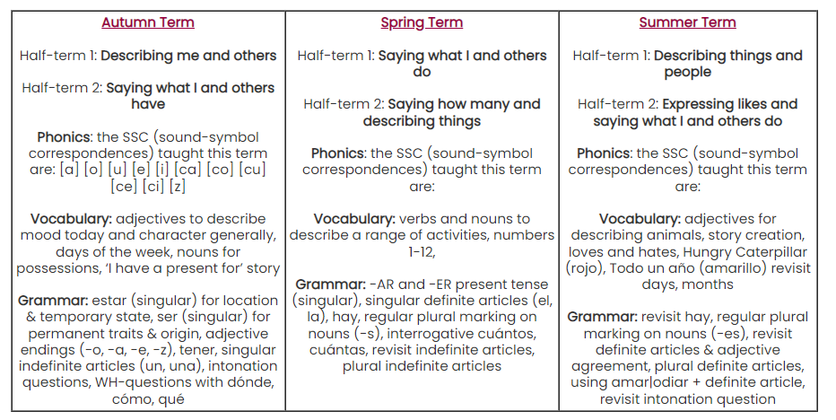
Year 3/4

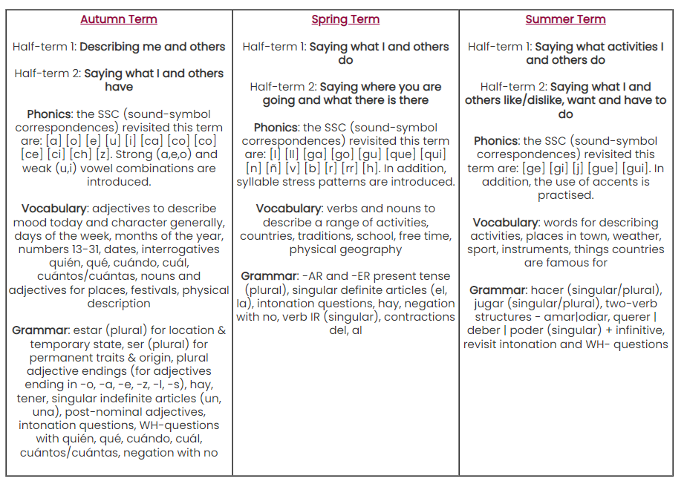
Year 5/6

