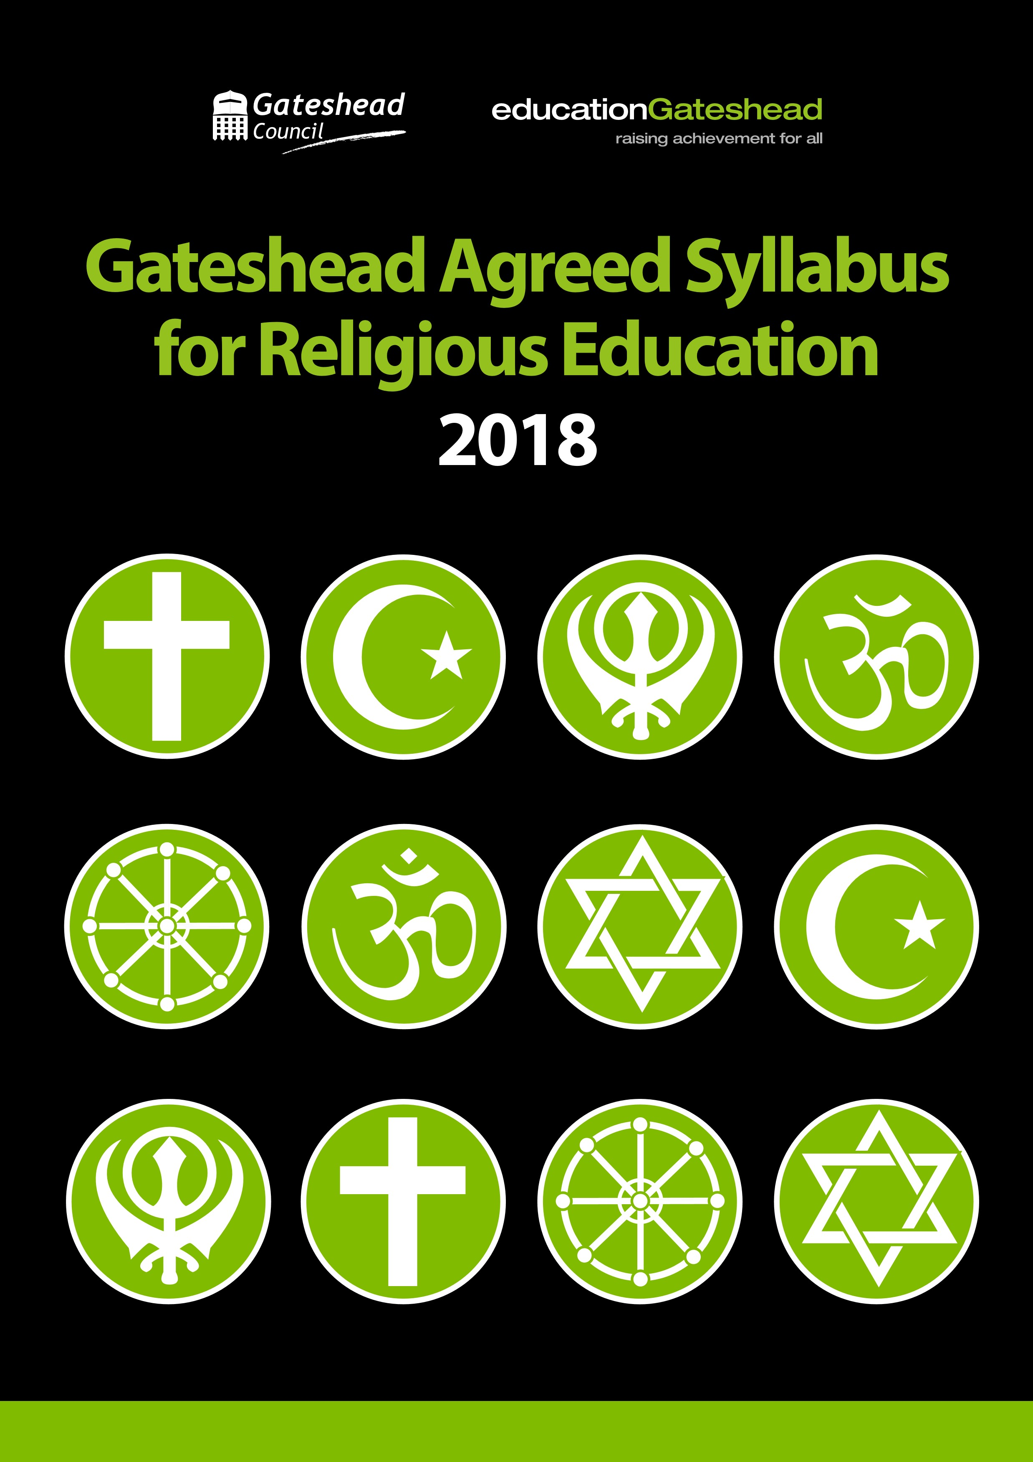
Acknowledgements
Gateshead SACRE is grateful to:
- Staffordshire SACRE for permission to use material from their Agreed Syllabus
- The teachers who helped with the development of this Agreed Syllabus
- Members of the Agreed Syllabus Committee
- Pauline Piddington, who is largely responsible for the presentation of the syllabus in its present form


Preface
All registered pupils in maintained schools, including those in reception settings, are entitled to receive Religious Education (RE). This Religious Education must be taught in accordance with an Agreed Syllabus for Religious Education that is determined locally through the Agreed Syllabus Conference. In Gateshead, work undertaken led to the conclusion that the syllabus, in terms of its content, continued to be relevant and acceptable to schools and no changes were required.
This booklet does not change that position. In terms of content, the syllabus remains unchanged. However, the booklet condenses the information about the syllabus and its delivery and also, in response to feedback we have received, reemphasises that schools may exercise freedom in the way in which they deliver the content. It is hoped that it will provide governors, school staff, parents and pupils with a more accessible presentation of the syllabus and so encourage its regular use.
In reaching our conclusions about the syllabus content, group members took into account the non-statutory National Curriculum Framework for RE [NCFRE] which was published by the Religious Education Council in 2013. This document highlights the need for children and young people to develop an understanding of and respect for the diverse faiths and communities that are increasingly part of the country and our own corner of it.
We have been delighted to see our own SACRE in Gateshead expand to include a representative of the Sikh faith and have been pleased also to be able to welcome a representative of the Humanist Society into our meetings as an observer.
We are greatly indebted to Staffordshire SACRE whose approach to presenting its syllabus gave us the encouragement and inspiration to reformat ours in this booklet. We have used its “Programme of Study Statements” and “Age Related Expectation Statements” almost in their entirety.
We hope that this new presentation of a familiar syllabus will be of help in assisting schools to continue to deliver excellent Religious Education in Gateshead.

Foreword
The Education Reform Act 2002 sets out the central aims of the school curriculum. They are:
- To promote the spiritual, moral, cultural, mental and physical development of learners at the school and within society; and
- To prepare learners at the school for the opportunities, responsibilities and experiences of adult life.
These general aims remain valid but our society is changing. Never has the need for greater understanding as a basis for mutual respect and tolerance been more pressing.
This is the very essence of RE: to equip our children and young people with the knowledge they need to understand how different people perceive their world and their place in it and how they answer and respond to the big questions in life:
- Why are we here?
- How should we live?
By Rev’d Brian Howell
Chairman, Gateshead SACRE
In presenting this document to you, we remain mindful of the need to avoid a proselytising approach.
The motivation for excellent Religious Education as presented here is the need to foster in our diverse and pluralist society the importance of recognising and respecting the significance to their believers of the many faith perspectives and non-faith perspectives of people in our communities.
With this in mind, in developing the syllabus, we have sought to present the principal faiths collectively as an aspect of human knowledge and experience.
We hope that you will find that it can help you in the work you are doing to support children and young people as they develop their philosophies for living, and to help them to live at peace with themselves, and in harmony with others.
The legal framework
Religious Education is part of a pupil’s entitlement from Reception through to the end of Sixth Form. All maintained schools are required to provide Religious Education for their pupils and headteachers must ensure that this is done.
All local authorities are required to establish a
Standing Advisory Council on Religious Education [SACRE] to provide advice to the local authority and to periodically review the Locally Agreed Syllabus.
The agreed syllabus must reflect that the religious traditions in Great Britain are principally Christian. Parents have the right to withdraw their children from all or part of religious education. Headteachers should refer to Section 386 of the Education Act 1996 and also to “Religious education in English schools: Non statutory guidance 2010” for more information in relation to this right.
The provision of Religious Education differs in different settings.
Community and Maintained schools must teach RE according to the requirements of the Locally Agreed Syllabus.
Foundation schools must teach RE according to the requirements of the Locally Agreed Syllabus unless the school is of a religious character in which case RE is defined by their Trust Deed.
In voluntary aided schools, RE should be taught in accordance with their Trust Deed. In voluntary controlled schools, RE should be taught according to the requirements of the Locally Agreed Syllabus but parents may request that RE should be provided in accordance with the Trust Deed.
Special schools should provide RE for all their pupils as far as practicable according to the status of the school.
In academies, RE should be provided as part of a broad and balanced curriculum in accordance with the requirements for Agreed Syllabuses.
Free schools should make provision for pupils’ entitlement to RE in accordance with the requirements for Agreed Syllabuses.
Sixth form colleges and further education colleges should provide RE for all students who wish to receive it.
Curriculum aims
The role of Religious Education is to help prepare and equip all pupils for life in contemporary Britain by enabling them to acquire a good level of religious literacy. This means to gain an understanding of the diverse beliefs and religious practices of our faith communities, to understand the secular world view held by a number of people in our society, and to respect the right of all people to make these very personal choices.
We believe that pupils should have the opportunity:
TO EXPLORE the teachings, beliefs and practices of the principal faiths and belief systems in our society.
This means that, for each of the faiths specified in the syllabus, they should be helped to acquire a core of knowledge and understanding of the key elements of the faith narrative, the principal stories, sacred texts, rituals, symbolism and lifestyles relating to them.
TO ENGAGE with the big questions about our life in the world, our value as people, our identity and our responsibilities.
This means that pupils should be helped to respond to the big questions that their experience of life raises and to be able to express their thoughts relating their experiences and responses to those of other individuals and groups.
TO REFLECT on the challenges that are presented by living in a diverse world and to develop the skills and attitudes that enable people to live well by successfully accommodating difference.
This means developing the ability to recognise bias, prejudice and discrimination in ourselves and others and to develop the ability to make informed judgements and responsible choices.
Section 375 of the Education Act 1996 requires that the Agreed Syllabus must reflect the fact that religious traditions in Great Britain are for the most part Christian but that the teaching and practices of the other religions represented in Great Britain must be taken into account. The ‘other religions’ that are specified in the Gateshead Agreed Syllabus are:
In Early Years and Primary:
- Judaism
- Hinduism
- Islam
In Secondary:
- All of the above and additionally
- Sikhism
- Buddhism
There is also an expectation that children will have some opportunity to learn about non-faith based belief systems such as Humanism and Atheism. There is potential for other faiths to be included in the syllabus where a school feels that this will be beneficial and appropriate.

Teaching and Learning
Suggestions for the delivery of the curriculum were provided in the original syllabus document, last issued in 2011. The suggestions provided there remain current but need not be used as a blueprint. They have been provided here as Appendix 2.
Some time ago we provided an outline of the aspects or “dimensions” of each of the four faiths to be covered in the primary syllabus. These were divided into six categories:
- Origins
- Narrative
- Principal beliefs
- The calendar
- People, places and practices
- Artefacts and symbols
This may be used as a checklist to support lesson planning and as a means of enabling pupils to meet the challenge presented in the curriculum aims,
that is, to explore, to engage and to reflect. We advise that the learning should be meaningful and so a secure understanding of the key information is more important than gaining a superficial view of everything on the list.

Teachers are free to build a curriculum that offers children the opportunities to research, discover, question, discuss, debate, evaluate and draw conclusions.
We have traditionally talked about “Learning about” and “Learning from” a study of religion. We are here suggesting a three part process and would encourage teachers to keep in mind the three aims of Exploring, Engaging and Reflecting in all of their planning, as a means not only of providing a rationale and structure to learning but also of providing opportunities for the assessment of pupils’ progress toward religious literacy.
The programme of study
There is an expectation that schools will allocate a reasonable amount of time to the Religious Education Programme of Study and that, whilst there will be a focus on the teaching of Christianity, pupils will have the opportunity to develop a good working knowledge of other key faiths.
At Key Stage 4, in line with recent changes to the GCSE specifications, there will be a focus on Christianity and one other religion.
Phase | Hours per year | Faiths
Reception |  | Christianity  Judaism  Hinduism  Islam
Key Stage 1 | 36 | Christianity  Judaism  Hinduism  Islam
Key Stage 2 | 45 | Christianity  Judaism  Hinduism  Islam
Reasonable time should be allocated for the study of RE. The expected time allocations and faiths to be included are:

Pupils should also develop an awareness of secular world views as appropriate. For example, Humanism and Atheism. Schools may also extend the range of faiths covered if they choose, in order to raise awareness of the great diversity of religion.
Schools are free to choose to deliver the subject through a regular weekly timetabled slot or through blocks of time. Schools may also choose to deliver faiths in a sequential way, recognising that the teaching of Christianity will be a constant in the programme, or they may choose to look at a number of faiths concurrently.
Returning to some of the same themes will enable pupils to develop and demonstrate growing skill and maturity in their exploration of, engagement with and reflection on religious and non-faith based values, beliefs and practice.
It is expected that pupils’ religious education will contribute to the development of their learning and skills across a wide range of aspects. For example:
Reading and research skills may be developed through the work that children do in exploring different religions and other world views.
Personal and social skills may be developed through their encounters with people, in school or in the context of educational visits, who can express faith experience and world views that are different from their own.
Their insight and reasoning may be developed through the discussion and questioning that will arise from their exploration of religious faiths and world views and the big questions and issues that this will provoke.
Self-awareness, understanding and empathy may be developed through their reflection and evaluation of their own and others’ beliefs.
Written and verbal communication skills may be developed through the pupils’ presentation of their learning in books, through individual or collaborative projects, in discussion and debate.
Their ability to identify connections may be developed through their study of the literary, historical and geographical aspects of their religious education.
For each faith, the key questions identified in the Gateshead Agreed Syllabus are:
For all key stages
- What do followers of this religion believe?
- Why are some people important to followers of this religion?
- What does this religion teach?
- How do followers of this religion worship?
- How do followers of this religion live?
- What do followers of this religion celebrate?
Additional questions for later key stages are:
- Religious beliefs, fact or fiction?
- Who inspires us and who inspires others? Why? Who sets a good example? Why?
- Teachings: relevant today or out of touch? A moral guide or a set of rules? Who decides and why?
- What is it like to live the life of a follower of a religion?
- What is the meaning and purpose of life?
The information provided in the grids that follow will, we hope, assist schools in developing a curriculum that enables exploration of these questions, encourages an active engagement with the issues, and enables children and young people to reflect on what they have learned.

Key Stage 1
Dimension | Curriculum opportunities Pupils should have the opportunity to:
Beliefs, teaching and sources  [See Narrative,  Principal Beliefs, and Sacred Texts in  Appendix 1] | Engage with stories and extracts from religious literature  and talk about their meanings | Explore stories about the lives and teachings of key religious figures | Find out about ways in which sacred texts are regarded, read and handled by believers
Practices and ways  of life  [See Principal Beliefs,  People, Places and Practices, and Festivals in Appendix 1] | Find out about how and when people worship and ask questions about why this is important to believers | Explore the preparations for and find out about the celebration of festivals | Identify the importance for some people of belonging to a religion and recognise the difference this makes to their lives
Expressing meaning  [See Principal Beliefs,  People, Places and Practices and Artefacts and Symbols in Appendix 1] | Explore as appropriate the special nature of artefacts used in  worship | Identify symbolic actions, gestures and rituals and talk about how they are used as part of worship and ceremonies | Engage with religious beliefs and ideas expressed through story, symbol and other visual forms of expression
Identity, diversity and belonging  [See Narrative, and  People, Places and  Practices in Appendix 1] | Reflect and respond to stories about belonging and relating to religious communities | Identify and ask questions about customs associated with particular religious communities | Find out about ceremonies in which special moments  in the life cycle are  marked
Meaning, purpose and truth  [See Narrative and  Principal Beliefs in  Appendix 1] | Ask and respond imaginatively to questions that are interesting or puzzling in the world | Listen to and ask questions about stories of individuals  and their relationship with God | Explore a range of stories and extracts from sacred writings and talk about the meaning they have for believers
Values and commitments  [See Narrative and  Principal Beliefs in  Appendix 1] | Reflect and respond to stories highlighting the morals and values of believers in practice | Reflect on examples of care and concern shown by believers and religious communities and explore reasons for these actions | Explore stories from religious traditions and find out about attitudes to the natural world

 |  | Key Stage 2
Dimension |  | Curriculum opportunities Pupils should have the opportunity to:
Beliefs, teaching and sources  [See Origins,  Narrative,  Principal Beliefs, and Sacred Texts in Appendix 1] | Explore the origins of sacred writings and consider their importance for believers today | Explore a variety of forms of literature found in sacred books and investigate a range of religious teachings | Explore the life of key religious figures and make links with teachings and practices of special significance to followers | Explore the meaning of a wide range of stories about the beginning of the world and reflect upon their importance for believers
Practices and ways of life | Compare and contrast the practice of religion in the home in different religious communities | Identify the main features and patterns of an act of worship and talk about the importance of worship for believers | Investigate some key features of religious festivals and celebrations and  identify similarities and differences | Investigate the life of a person who has been inspired by their faith and make links between belief and action
Expressing meaning | Explore the symbolic use of a range of objects, sounds, visual images, actions and gestures and consider the intended meaning they might have for believers | Explore the meaning of stories drawn from religious sources and reflect on the significance of key words, phrases or expressions | Compare and  contrast the use of symbols, actions and gestures used in  worship by different communities | Identify some of the ways in which religions name and describe attributes of God and make links with belief and practice
Identity, diversity and belonging | Explore the diversity of a range of religious traditions and identify and reflect on similarities and differences | Find out about the activities of a local religious community and make links with those activities and key religious teachings | Research some key events in the development of a religious tradition and explain the impact on believers today | Investigate the importance  for believers of ceremonies in which special moments  in the life cycle are  marked
Meaning, purpose and  truth | Raise questions about issues that cause people to wonder and investigate some answers to be found  in religious writings and teachings | Investigate and reflect on a range of religious responses to suffering, hardship and death | Investigate stories about God’s relationship with people and suggest how for some people this helps  them to make sense  of life | Make links between belief and action and reflect on how this might have local, national and international impacts
Values and commitments | Explore rules for living found in sacred writings and teachings and ask questions about their impact on the lives of believers | Investigate ceremonies associated with joining or belonging to a faith community and talk about the meaning of commitment | Engage with a variety of people about their beliefs and values and ask questions about the way commitment  affects their lives | Explore religious stories and teachings about the environment and  identify and reflect on their impact on behaviour

Identity, diversity and belonging | Reflect critically on the advantages and disadvantages of inheriting a religious tradition and reflect on the changing impact of religion and beliefs on community and society over time | Reflect critically on the variety of practice within and between faith groups and reflect on issues which unite and divide religious traditions
Meaning, purpose and truth | Engage with and analyse responses to philosophical and paradoxical questions from a range of faith perspectives | Investigate and interpret a variety of religious and spiritual experiences and reflect on differing responses and impacts
Values and commitments | Explore ways in which religious communities help their members respond positively to life’s dilemmas | Raise questions about contemporary personal, moral and social issues  and analyse the variety of religious responses

Assessment
Units of work should be planned to develop the three curriculum aims and enable regular review of pupils’ progress. Age related expectations are given in relation to each of the three curriculum aims. In summary, the objectives are to enable children to acquire knowledge, understand themselves and other people better, and respond appropriately to difference.
The assessment framework provided here uses terminology that will be familiar to you in other contexts. It is suggested that pupils are assessed as:
WTS – Working towards the expected standard for their age
EXS – Working at the expected standard for their age

GDS – Working at greater depth within the expected standard
 | Age related expectations in primary school for RE
 | By the end of Reception
Explore | Pupils can talk about past and present events in their own lives and in the lives of family members. They can identify similarities and differences in relation to places, objects, and materials including faith buildings.
Engage | Pupils can describe their own immediate environment and can say how environments might vary from one another and what things make them special.
Reflect | Pupils know that other children do not always enjoy the same things as them and they accommodate those differences. They can talk about similarities and differences between themselves and other people and among different families, communities and traditions.
 | By the end of Year 1
Explore | Pupils use some religious words and phrases relating to the practices of faiths they have explored. They can recall some religious stories and can recognise some symbols and artefacts relevant to the faiths they are learning about.
Engage | Pupils can talk about their experience of the world around them and especially what they value and what concerns them.
Reflect | Pupils can demonstrate their understanding that there is more than one religious tradition or faith community.
Continued on next page
 | Age related expectations in primary school for RE continued
 | By the end of year 2
Explore | Pupils use religious words and phrases to identify some features of religion and its importance to some people. They begin to show awareness of the similarities in religions including key questions raised by believers. They can talk about how religion is expressed in different ways and can explain the meanings of some religious symbols and rituals.
Engage | Pupils have an awareness of some of the questions that cause people to wonder and are difficult to answer. They can express and discuss ideas about right and wrong.
Reflect | Pupils can identify more than one religious tradition or faith community and can describe some of the distinctive features of those traditions or communities.
 | By the end of year 3
Explore | Pupils demonstrate their developing religious vocabulary in describing some key features of some religions and identifying their differences. They can make links between beliefs, practices and sources, including religious stories and texts. They begin to identify the impact religion has on believers’ lives. They can describe some forms of religious expression.
Engage | Pupils learn to ask important questions about values, commitments and beliefs, making links between their own and others’ responses, attitudes and behaviour.
Reflect | Pupils can identify and distinguish between the faiths being explored and can express some awareness of their identity within or outside these faiths. They show an understanding of the implications of living in a diverse society.
 | By the end of year 4
Explore | Pupils use their expanding religious vocabulary to describe and show understanding of sources, practices, beliefs, ideas and experience. They can describe some of the differences and similarities both within and between religions. They can talk about the impact of religion on people’s lives and can explain the meanings of some forms of religious expression.
Engage | Pupils discuss fundamental questions about identity and belonging, about meaning and purpose in life, about values and commitment. They can recognise the implications and consequences attaching to making choices between right and wrong.
Reflect | Pupils can apply their ideas about identity and commitment to their own and other people’s lives. They can say who and what influences and inspires them and can give reasons for their ideas. They can discuss their experience of living alongside people who have a different faith or point of view.
Continued on next page
 | Age related expectations in primary school for RE continued
 | By the end of year 5
Explore | Pupils use their widening religious vocabulary to explain the impact of beliefs on individuals and communities. They show an understanding of why people belong to religions and are able to describe similarities and differences and how these illustrate distinctive beliefs within and between religions. They can explain how religious sources are used to provide answers to ethical questions.
Engage | Pupils raise and respond to fundamental questions of identity, belonging, meaning, purpose, truth, values and commitments. They can relate these to their own experience and to the experience of others and can make a clear connection between their point of view and their actions.
Reflect | Pupils can explain what influences and inspires them. They can talk about the opportunities and challenges that arise from individual and group commitments in a diverse world. They can talk about the implications for themselves and other people of holding particular beliefs and values.
 | By the end of year 6
Explore | Pupils use religious and philosophical vocabulary to give informed accounts of religions and beliefs. They interpret sources and arguments, explaining the reasons that are used in different ways by different traditions to provide answers to ethical issues. They interpret the significance of different forms of religious, spiritual and moral expression.
Engage | Pupils use reasoning and examples to explore the relationship between beliefs, teachings and world issues. They express insights into their own and others’ views on fundamental questions of identity and belonging, meaning, purpose and truth.
Reflect | Focusing on values and commitments, pupils consider their own responses to the opportunities and challenges of living in a diverse world whilst taking account of the views and experiences of others. They are able to talk about examples of religious cooperation, and why this is sometimes difficult.
 | By the end of Key Stage 3
Explore | Using a wide religious and philosophical vocabulary, pupils demonstrate a coherent understanding of a range of religions and beliefs by analysing issues in a faith context. They can describe the influence of history and culture on aspects of religious life and practice. They use a variety of sources, evidence and forms of expression in their study of religion, spirituality and ethics.
Engage | Pupils identify and express their responses to fundamental questions of meaning, purpose, truth and ethics. They can express a clear sense of their own identity.
Reflect | Pupils are able to evaluate and understand human relationships, belonging, identity, social values and commitments appropriate to living well in a diverse world in the context of religious and other views. They can identify opportunities and successes for positive interfaith collaboration and also examples of prejudice and discrimination on religious grounds and its impact.
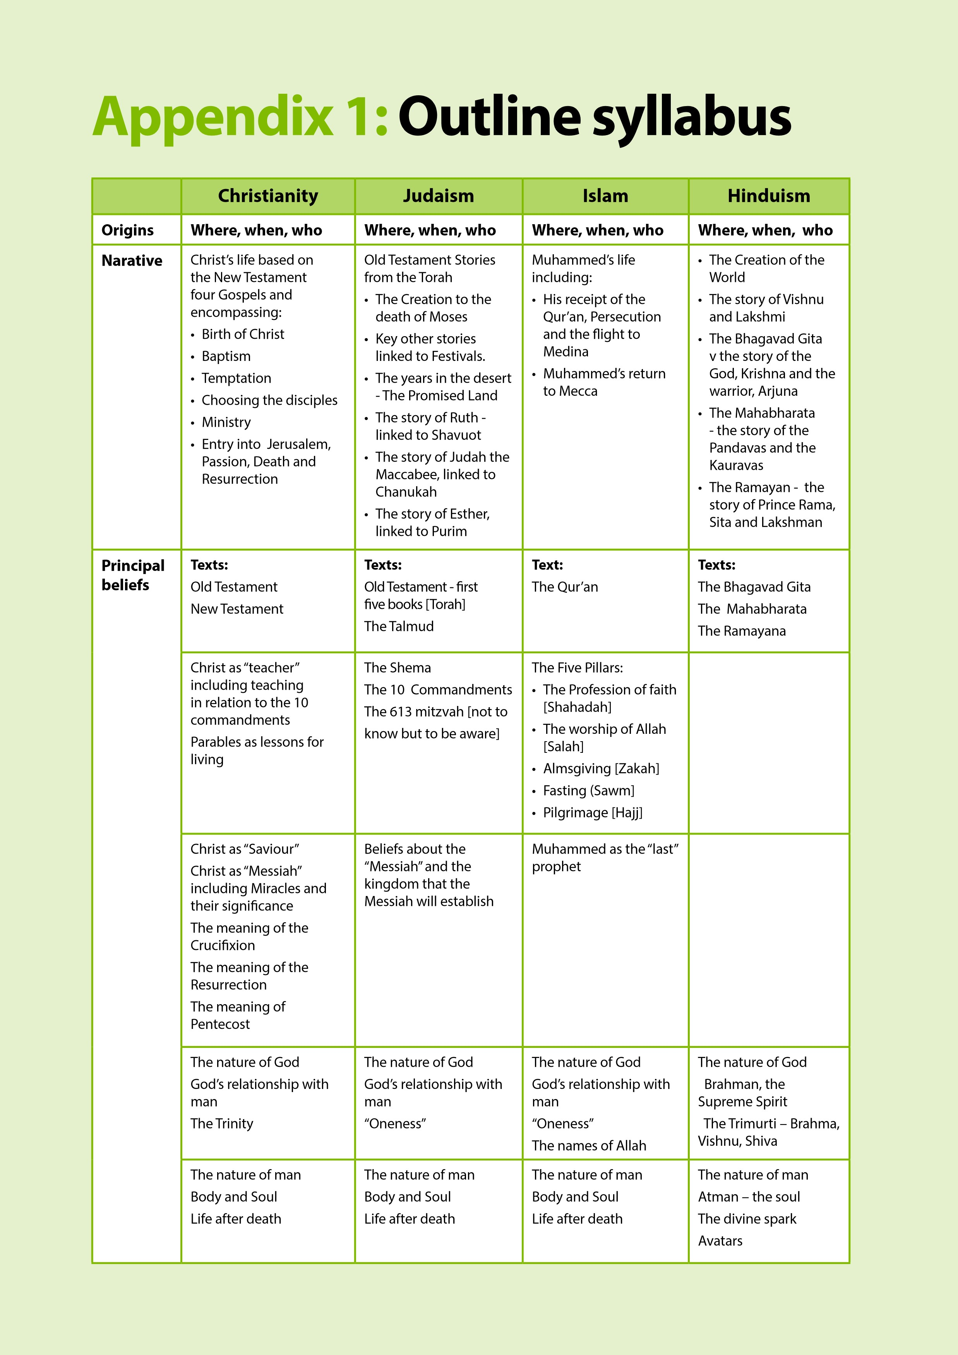
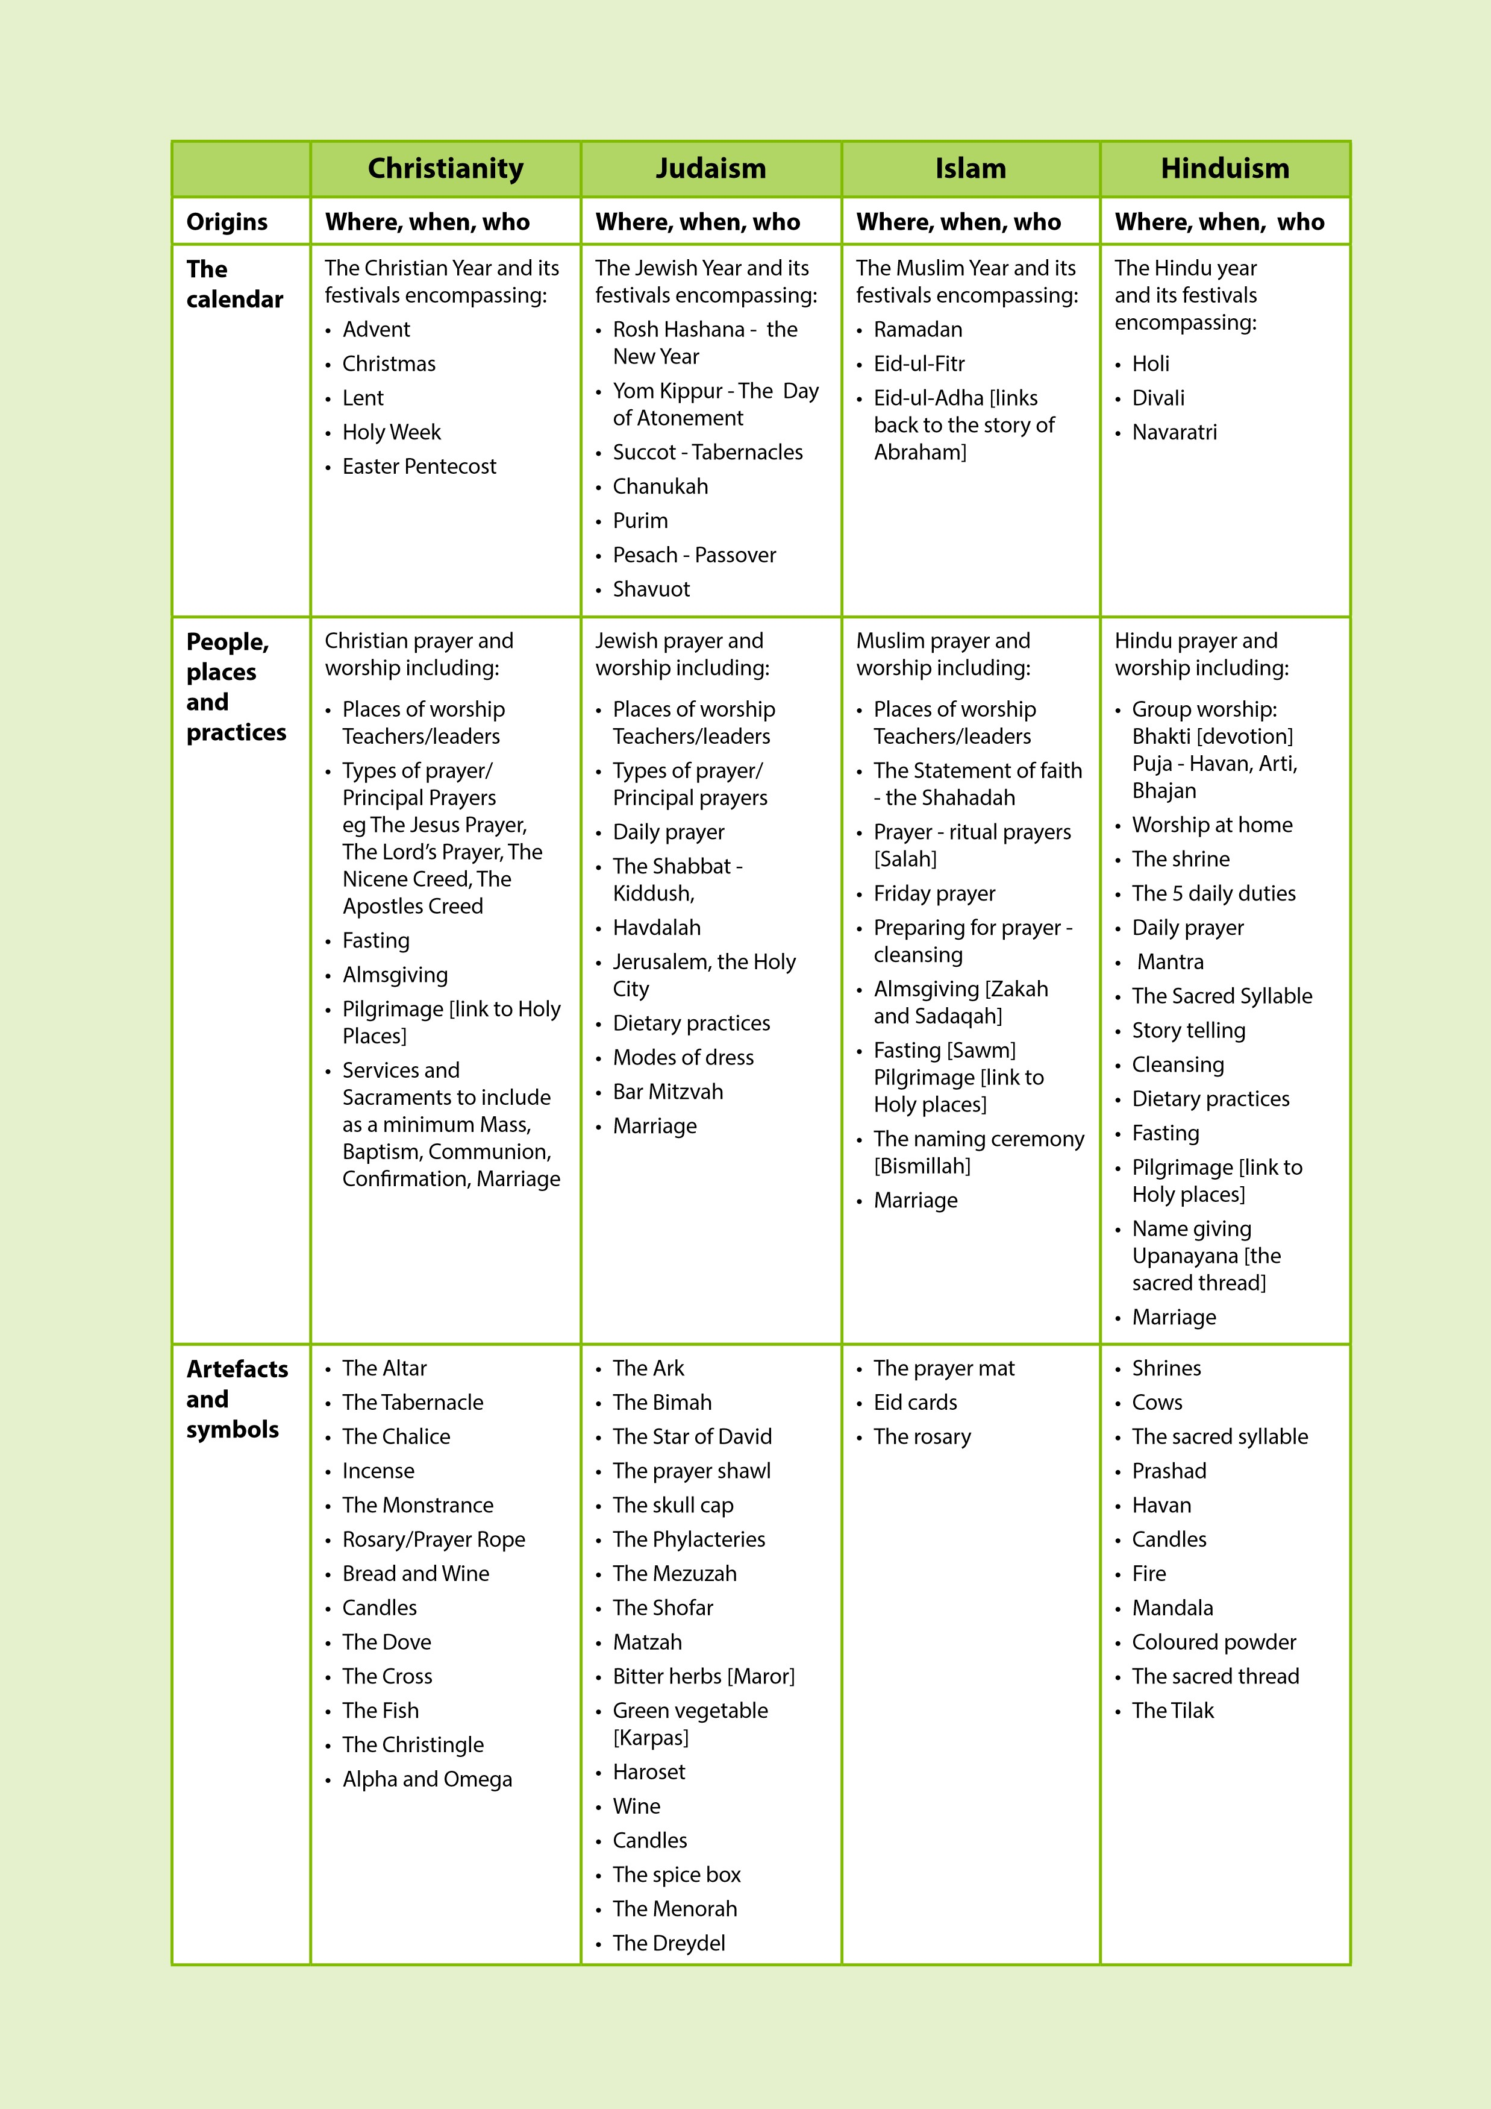

Appendix 2:  Suggested programmes of study  These programmes of study have been taken from the 2011 Gateshead Agreed Syllabus. They have been included because some teachers found them helpful.  They should be regarded as suggestions only. Schools are free to devise their own programmes of study provided that they cover all the elements outlined above.
  Key Stage One | Links to SOW
  Key Stage One | Learning about JUDAISM | •  God: stories from the Torah: creator,  loving, caring, having authority  •  Shema | •  Aspects of the life of Moses and  others: for example, Joseph and Ruth  •  The role of the rabbi | •  The Torah: rules, values and stories,  significance to Jewish people | •  Synagogue: its functions and features;  importance to the Jewish community  •  Worship activities including prayer  •  Local Jewish communities | •  Home and family life today  •  The significance of religious objects  such as mezuzah; tallit; kippah | •  Shabbat, Purim, Chanukah, Sukkot:  Symbols, customs and practice,  significance for Jewish people
  Key Stage One | Learning about CHRISTIANITY | •  God, using Old and New Testament sources: creator, loving, caring, having  authority  •  Jesus: birth, aspects life and teaching, effect on others then and now,  aspects of Easter | •  The role of the minister/vicar etc  •  St Bede or another North Eastern saint* | •  The Bible: special book for Christians, source of authority, teaching and help,  love, caring, trust, forgiveness  •  Stories from the Old and New Testaments, for example Joseph, The Lost  Sheep* | •  Church: its functions and features/Importance to Christians  •  Worship activities including praise and prayer  •  Local Christian communities/religious buildings (church, chapel etc), | •  Becoming a ‘follower of Christ’ including baptism, being a disciple/follower  of Jesus  •  Jesus’ teachings: two great commandments, other ‘rules’ for living  •  Christian attitudes and values: love, care, forgiveness and honesty, valuing  self, others and the world  •  Lives of some Christians: famous and local | •  Christmas, Easter, Harvest: symbols, customs and practice, significance for  Christians
  Key Stage One | Key questions | What do followers of this  religion believe? | Why are some people  important to followers of  this religion? | What does this religion  teach? | How do followers of this  religion worship? | How do followers of this  religion live? | What occasions do  followers of this religion  celebrate?
Schools are free to choose which stories and people they study in the light of available resources, taking account of continuity and progression through and across key stages
Key Stage Two | Links to SOW
Key Stage Two | Learning about HINDUISM | •  Aum symbol  •  Trimurti: Vishnu, Shiva, Brahma  •  Hindu deities: e.g Rama, Krishna,  Ganesha, Lakshmi, Hanuman, Kali,  Durga: characteristics of God;  •  Creation | •  Avatar  •  MK Gandhi | •  Stories: insights and teachings  •  Ramayana  •  Purana | •  Mandir: its functions and features;  importance to the Hindu  community  •  Worship activities: puja
Key Stage Two | Learning about ISLAM | •  Belief in one true God (Allah)  •  Nature of Allah through some of  the 99 names  •  Beliefs about creation | •  Aspects of the life of Muhammad,  prophet of Allah  •  Ibrahim, Musa, Dawud  •  The role of the imam | •  Qur’an: revealed to Muhammad;  importance; how it is used and  treated; source of authority and  teaching  •  Words and meaning of some  portions of the Qur’an  •  The ‘Shahadah’ | •  Mosque: its functions and features;  importance to the Muslim  community  •  Worship activities including wudu  and prayer
Key Stage Two | Learning about CHRISTIANITY | •  Nature of God: as revealed in the Bible:  the Trinity  •  God and creation: caring for the world  •  God’s relationship with humankind:  Covenant  •  Jesus’ birth, ministry, death, resurrection,  ascension, return  •  Incarnation, redemption, salvation  •  Teachings and miracles of Jesus: Biblical  context; significance today  •  The effect Jesus had on the people  around him then and now | •  Discipleship: the first disciples  •  Lives of great Christians: St Paul and  others*  •  St Cuthbert or another northern saint* | •  The Bible: origin, structure, content and  use  •  Importance of the Bible for believers; the  significance of some of its messages for  today | •  Aspects of Christian community  (  worship, prayer, ritual and ceremony)  expressed in different traditions and  parts of the world.  •  ‘Church’ as a body of believers  •  Local Christian place of worship: its  significance for those who attend; how it  is used
Key Stage Two | Key questions | What do followers of this  religion believe? | Why are some people  important to followers of  this religion? | What does this religion  teach? | How do followers of this  religion worship?
Schools are free to choose which stories and people they study in the light of available resources, taking account of continuity and progression through and across key stages
Continued on next page
Key Stage Two  continued | Links to SOW |  |  | *  Schools are free to choose which stories and people they study in the light of available resources, taking account of continuity and progression through and across key stages | Key Stage Three | Links to SOW
Key Stage Two  continued | Learning about HINDUISM | •  Belonging and identify: birth,  naming, sacred thread ceremony  •  Family / home life  •  Samskaras  •  Values: respect; caring; ahimsa;  vegetarianism | •  Divali; Holi; Raksha Bandhan |  | Key Stage Three | Content Focus | •  Who or what is God and is God real?  •  Jesus – human and divine?  •  How do we know what is true?  •  What is meant by the sanctity of life?  •  Is death the end?  •  How did the world begin? (Science and Religion) | •  Jesus  •  Muhammad / Moses/The Ten Gurus/Gautama Buddha and, for example: Jonathan Edwards, Martin Luther King,  Desmond Tutu, Pope John Paul II, Basil Hume, Sister Winifred (Gateshead), Bono, James Mawdsley, Jackie Pullinger, Dalai  Lama, Aung San Suu Kyi, Chofetz Chaim (Rabbi Yisrael Meir HaCohen Kagan), Dr Judith Grunfeld, Gandhi, Malcolm X,  Nelson Mandela, Bob Geldof*
Key Stage Two  continued | Learning about ISLAM | •  Family life  • Local Muslim communities  •  Ramadan  •  Hajj | •  Eid-ul-Fitr  •  Eid-ul-Adha
Key Stage Two  continued | Learning about CHRISTIANITY | •  Belonging and identity for Christians:  baptism; confirmation; holy communion  •  Christian belief and practice across the  worldwide Church  •  Guidance: commandments; beatitudes  •  People inspired by God: e.g. Desmond  Tutu, local minister, people known to the  pupils*  •  Pilgrimage: places; significance | •  Harvest; Christmas; Easter; Pentecost;  Ascension: significance for Christians
Key Stage Two  continued | Key questions | How do followers of this  religion live? | What occasions do  followers of this religion  celebrate? |  | Key Stage Three | Key questions | Religious beliefs, fact or  fiction? | Who Inspires us and who  inspires others? Why? Who  sets a good example and  Why?
Schools are free to choose which stories and people they study in the light of available resources, taking account of continuity and progression through and across key stages

 | *  Schools are free to choose which stories and people they study in the light of available resources, taking account of continuity and progression through and across key stages
  Key Stage Three  continued | Links to SOW
  Key Stage Three  continued | Content focus | •  Bible: Old Testament, Commandments  •  Jesus, Beatitudes, values/moral codes  •  St Paul’s Letters  •  Relationships  •  The Church poverty/wealth  •  The Qur’an/the Tenakh  •  Crime and punishment  •  Talmud/Guru Granth Sahib/Buddha and Dhammapada | •  Relationships  •  Growing up in Britain today  •  Rites of Passage and marking birth, maturity, partnership and death  •  Community life  •  How does a person become a Christian/Muslim/Jew etc?  •  What is the difference between a pilgrim and a tourist?  •  Expressions of faith: what do people do? (e.g. worship, celebrations, art, music, dance, writings, community action)  •  “God is one, but religions are many.” Do you agree? Why?  •  Conflict: prejudice, persecution – why is there so much pain caused by humanity? What part does religion play in local  and world conflicts?  •  Service to God and service to others | •  What is my life for? Where did I come from? Where am I going? How should I live?  •  Why do people suffer? What is evil? How can it be reduced?  •  Why forgive? (Conflict, reconciliation, forgiveness)  •  Why and how should we respect and appreciate (physically and spiritually) ourselves, other people, living creatures and  the world?
  Key Stage Three  continued | Key questions | Teachings – relevant today  or out of touch?  A moral guide or a set of  rules?  Who decides and why? | What is it like to live the life  of a follower of a religion? | What is the meaning and  purpose of life?

Underpinning the key questions | Links to SOW
Underpinning the key questions | Learning about ISLAM | •  Allah: what does the Qur’an say?  •  Shahadah  •  ‘shirk’  •  Day of Judgement, Ummah, Akhirah and Qadar | •  The life of Muhammad: historical context;  significance in Islam; exemplifying Islamic  teaching | •  Qur’an: revealing; how and why it is revered and  used  •  Significance of Hadith, Sirah and Sunnah  •  Teachings found in Islam | Re-visit:  •  Mosque: features and functions; significance  •  worship activities | •  Family and community life  •  Salah, Sawm, Zakah and Hajj  •  Differences within Islam  •  Values, attitudes and behaviour: environmental  issues; poverty; war; prejudice and discrimination;  alcohol and drug abuse; relationships; marriage  and divorce; charity; role of women; religious  liberty  •  Being a Muslim in Britain today | •  Eid ul-Adha  •  Eid ul-Fitr  •  Laylat al-qadr  •  Al-Hijra  •  Muhammad’s birthday
Underpinning the key questions | Learning about HINDUISM | •  Nature of God  •  Beliefs and values expressed through deities  •  Atman, seva, karma, dharma, samsara, moksha | •  Sri Ramakrishna  •  Gandhi | •  Hindu scriptures: Bhagavad Gita; Mahabharata; Vedas  •  How scriptures are used  •  Teachings of Krishna  •  Accounts of creation | •  Mandir: features and functions; significance  •  Puja  •Forms of worship: importance; home and mandir | •  Community life  •  Values and attitudes  •  Symbols of light and fire  •  Birth, initiation  •  Values, attitudes and behaviour: environmental issues;  poverty; war; prejudice and discrimination; alcohol and  drug abuse; relationships; marriage and divorce; charity;  role of women; religious liberty  •  The gunas  •  Being a Hindu in Britain today | •  Janamashtami  •  Divali  •  Vasanta Panchami
Underpinning the key questions | Continuing with previous key  stages | What do followers of this religion  believe? | Why are some people important to  followers of this religion? | What does this religion teach? | How do followers of this religion  worship? | How do followers of this religion  live? | What do followers of this religion  celebrate?

Underpinning the key questions  continued | Links to SOW
Underpinning the key questions  continued | Learning about SIKHISM | •  God  •  Mool Mantar | •  Guru Nanak  •  The Ten Gurus: teachings and influence on Sikh life | •  Guru Granth Sahib: significance; how it is used and  revered; selected passages  •  Stories about the Gurus and their teachings | •  Gurdwara: features and functions; significance;  •  Worship activities  •  Explore Sikh practices, including the wearing of  the 5Ks | •  Family and community life  •  Values and attitudes  •  Significance of the 5Ks?  •  Birth, initiation  •  Rahit,Kurahit,Haumai,Sewa  •  Values, attitudes and behaviour: environmental  issues; poverty; war; prejudice and discrimination;  alcohol and drug abuse; relationships; marriage  and divorce; charity; role of women; religious  liberty  •  Being a Sikh in Britain today | •  Baisakhi  •  Birthdays of Guru Nanak and Guru Gobind Singh  •  Divali  •  Martyrdom of Guru Tegh Bahadur
Underpinning the key questions  continued | Learning about JUDAISM | •  God: what does the Torah say?  •  Shema  •  Meaning of ‘struggling’ with God | •  Abraham  •  Moses  •  The Rabbi | •  Torah, Tenakh and Tallmud: significance – how they are  used  •  teachings | •  Synagogue: features and functions; significance  •  Worship activities | •  Family and community life  •  Shabbat  •  Noachide laws and the Halakhah: influence on everyday  Jewish life  •  Israel  •  Holocaust  •  Differences within Judaism  •  Values, attitudes and behaviour: environmental issues;  poverty; war; prejudice and discrimination; alcohol and  drug abuse; relationships; marriage and divorce; charity;  role of women; religious liberty  •  Being a Jew in Britain today | •  Rosh Hashanah  •  Yom Kippur  •  Pesach  •  Chanukah  •  Purim  •  Sukkot
Underpinning the key questions  continued | Continuing with previous key  stages | What do followers of this religion  believe? | Why are some people important to  followers of this religion? | What does this religion teach? | How do followers of this religion  worship? | How do followers of this religion  live? | What do followers of this religion  celebrate?


